NORFOLK COUNTY COUNCIL proposes to make a Temporary Traffic Order affecting the U59293 Hemblington Road from its junction with the C429 Norwich Road for a distance of 40 metres northwards in the PARISH OF STRUMPSHAW because of a new water connection.

The road will be temporarily closed (except for access) from 29th October 2018 to 31st October 2018 for the duration of the works, expected to be 3 days within the period.

Alternative route is via: Norwich Road, Chapel Road, Blofield Road, Lingwood Road (Blofield/ Lingwood and Burlingham/ Strumpshaw).

(If necessary the restriction could run for a maximum period of 18 months from the date of the Order).

Penalty: £1000 maximum fine on conviction and/or endorsement for contravention.

In the event of the start date being delayed the new start date will be displayed on site in advance.

The person dealing with enquiries at Norfolk County Council is Martin Dixon (Community and Environmental Services) Telephone 0344 800 8020.

Dated this 12th day of October 2018

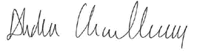

Abdus Choudhury

Practice Director

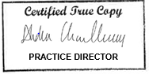

County Hall

Martineau Lane

Norwich

NR1 2DH

