NORFOLK COUNTY COUNCIL has made a Temporary Traffic Order affecting Strumpshaw Road from its junction with Buckenham Lane for 225m eastwards in the PARISH OF LINGWOOD AND BURLINGHAM because of Openreach pole renewal works.

The road will be temporarily closed (except for access) between 09:30 and 15:30 on 12th January 2022 for the duration of the works expected to be about 6 hours within the period.

Alternative route is via: Buckenham Lane, Norwich Road, High Way, Buckenham Road.

(If necessary the restriction could run for a maximum period of 18 months from the date of the Order).

Penalty: £1000 maximum fine on conviction and/or endorsement for contravention.

In the event of the start date being delayed the new start date will be displayed on site in advance.

The person dealing with enquiries at Norfolk County Council is Vinnie Purdy (Community and Environmental Services) Telephone 0344 800 8020.

Dated this 7th day of January 2022

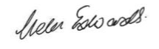

Helen Edwards

Chief Legal Officer

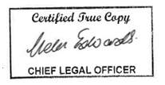

County Hall

Martineau Lane

Norwich

NR1 2DH

Map and plan of road closure and alternative diversion route